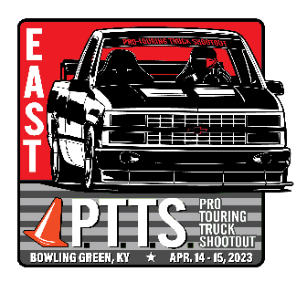
PTTS 2023 Overall Auto-X & Speed-n-Stop Racer Results
MC Class Overall Points
Position | Truck | Points
1 | 16 | 198
2 | 31 | 197
3 | 51 | 196
4 | 43 | 98

Outlaw Overall Points
Position | Truck | Points
1 | 50 | 198
2 | 5 | 195
3 | 11 | 193
4 | 39 | 192
4 | 23 | 96

Novice Overall Points
Position | Truck | Points
1 | 4 | 198
2 | 47 | 197
3 | 55 | 98

